# Section 1

#### Component

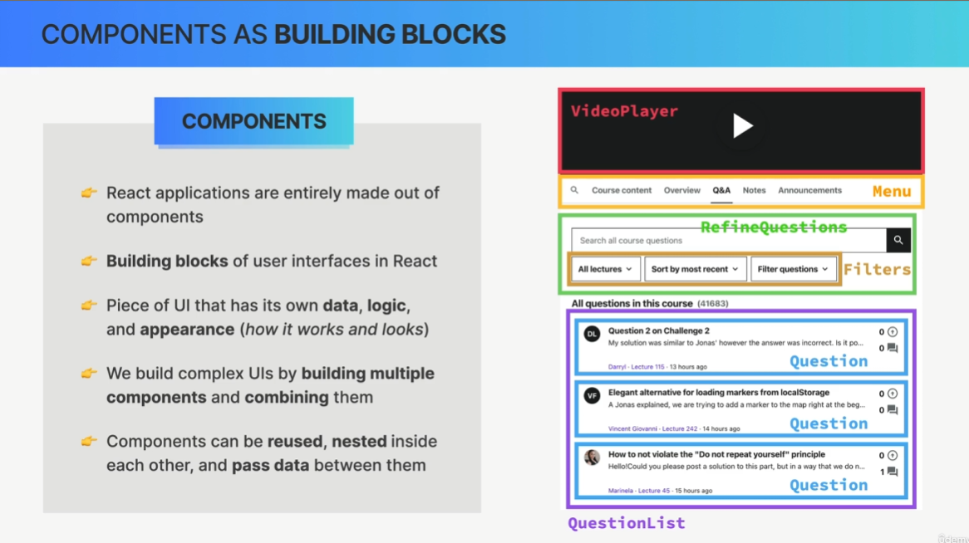

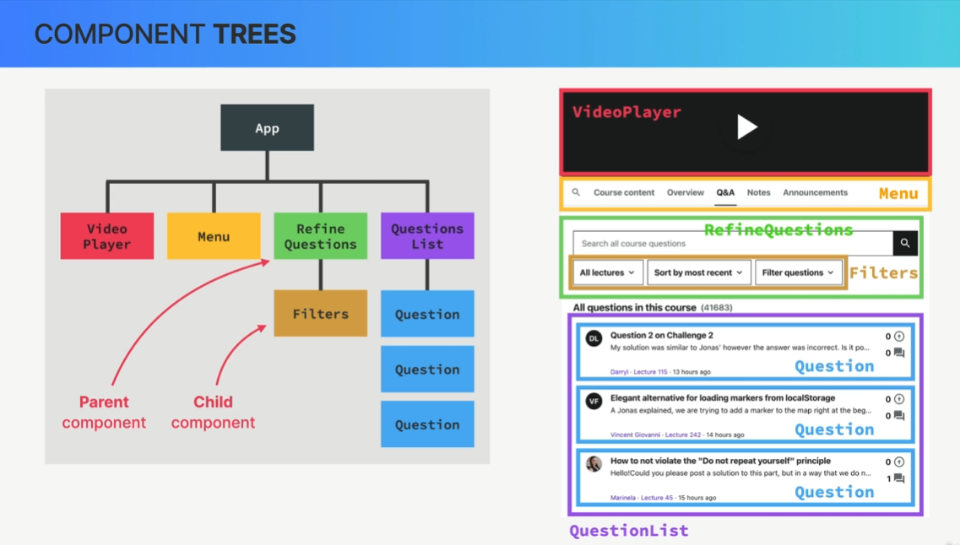

in React is just a function. Now, these functions in React, so these components can return something called JSX, which is a syntax that looks like HTML and describes what we can see on the screen.

##### JSX

It is basically just like HTML, but we can add some JavaScript to it.  
  
- Declarative syntax to describe what components look like and how they work

So when we try to build UIs using vanilla JavaScript, we will by default use an imperative approach. This means that we manually select elements, traverse the DOM, and attach event handlers to elements. Then each time something happens in the app like a click on the button, we give the browser step-by-step instructions on how to mutate those thumb elements until we reach the desired updated UI. So in the imperative approach, we basically tell the browser exactly how to do things.

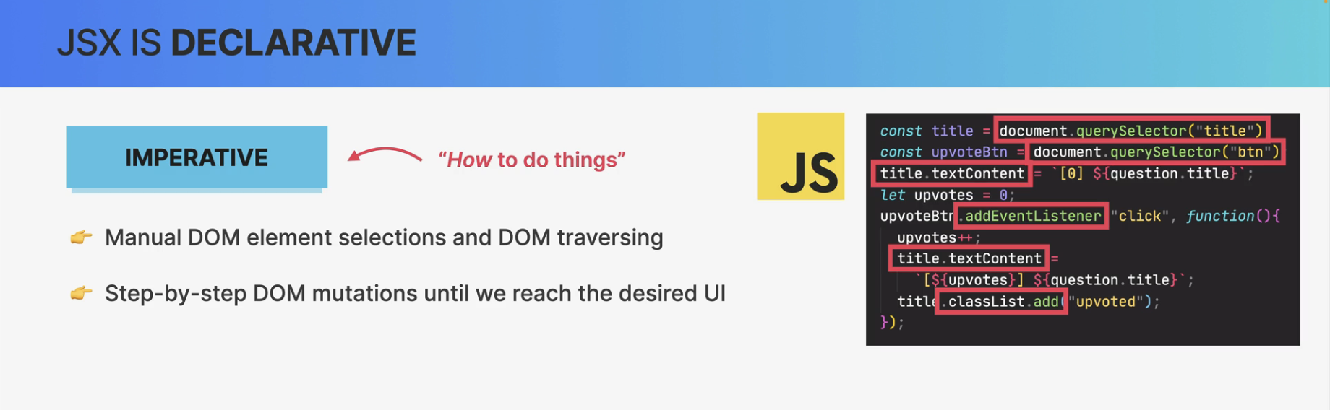

So, a declarative approach is to simply describe what the UI should look like at all times,

always based on the current data that's in the component.

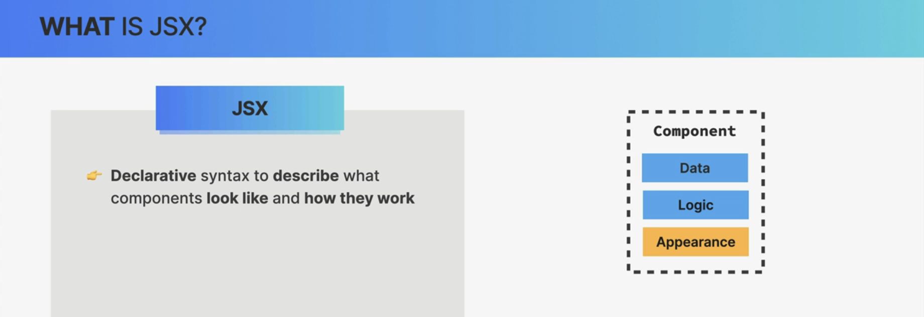

* Components must return a block of JSX

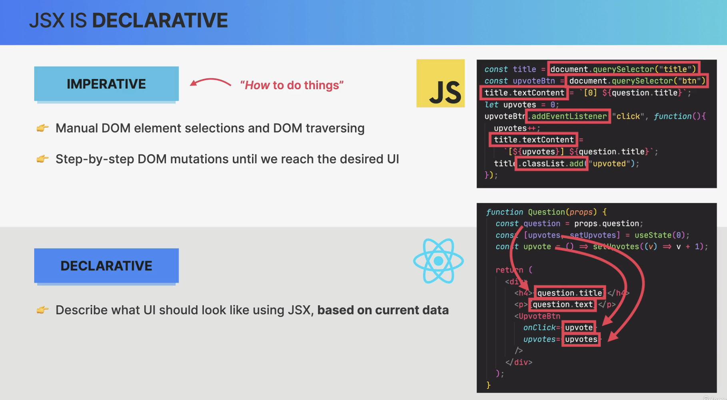

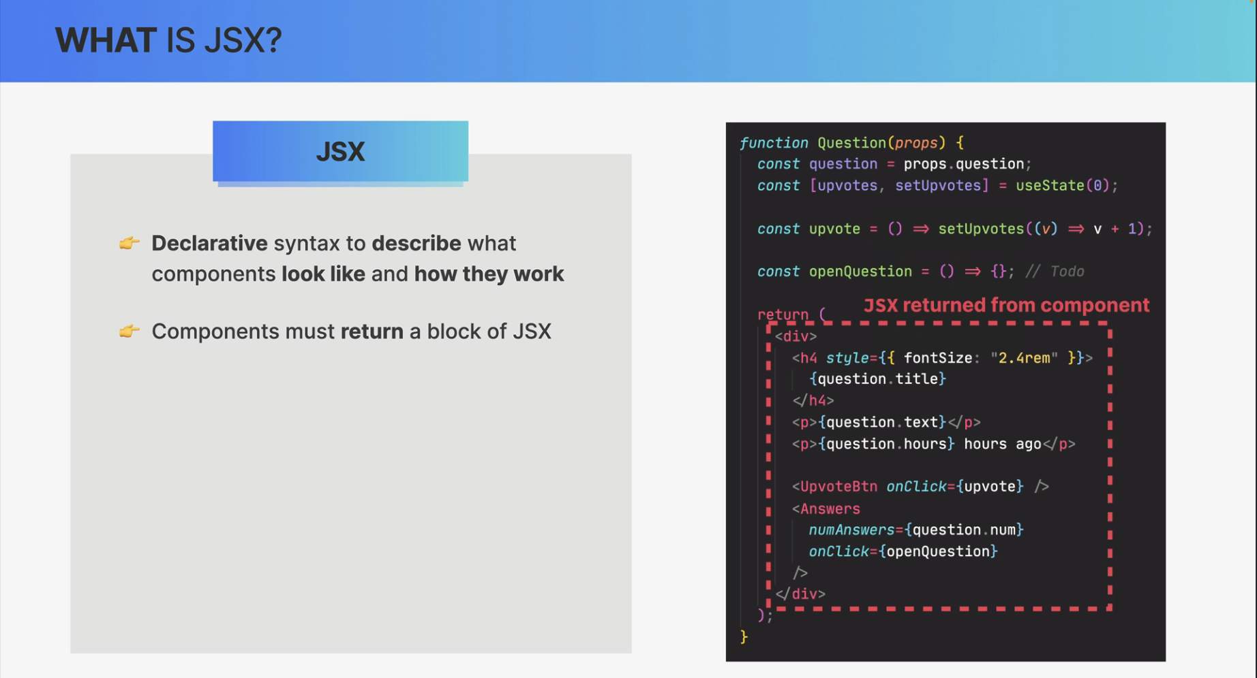

* Extension of JavaScript that allows us to embed JavaScript, CSS, and React components into HTML

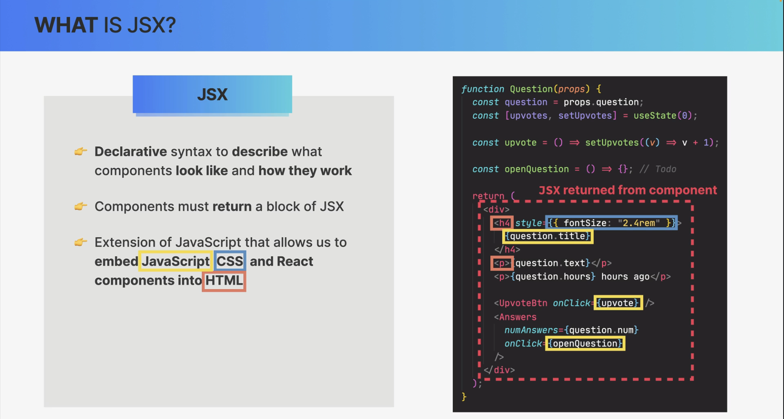

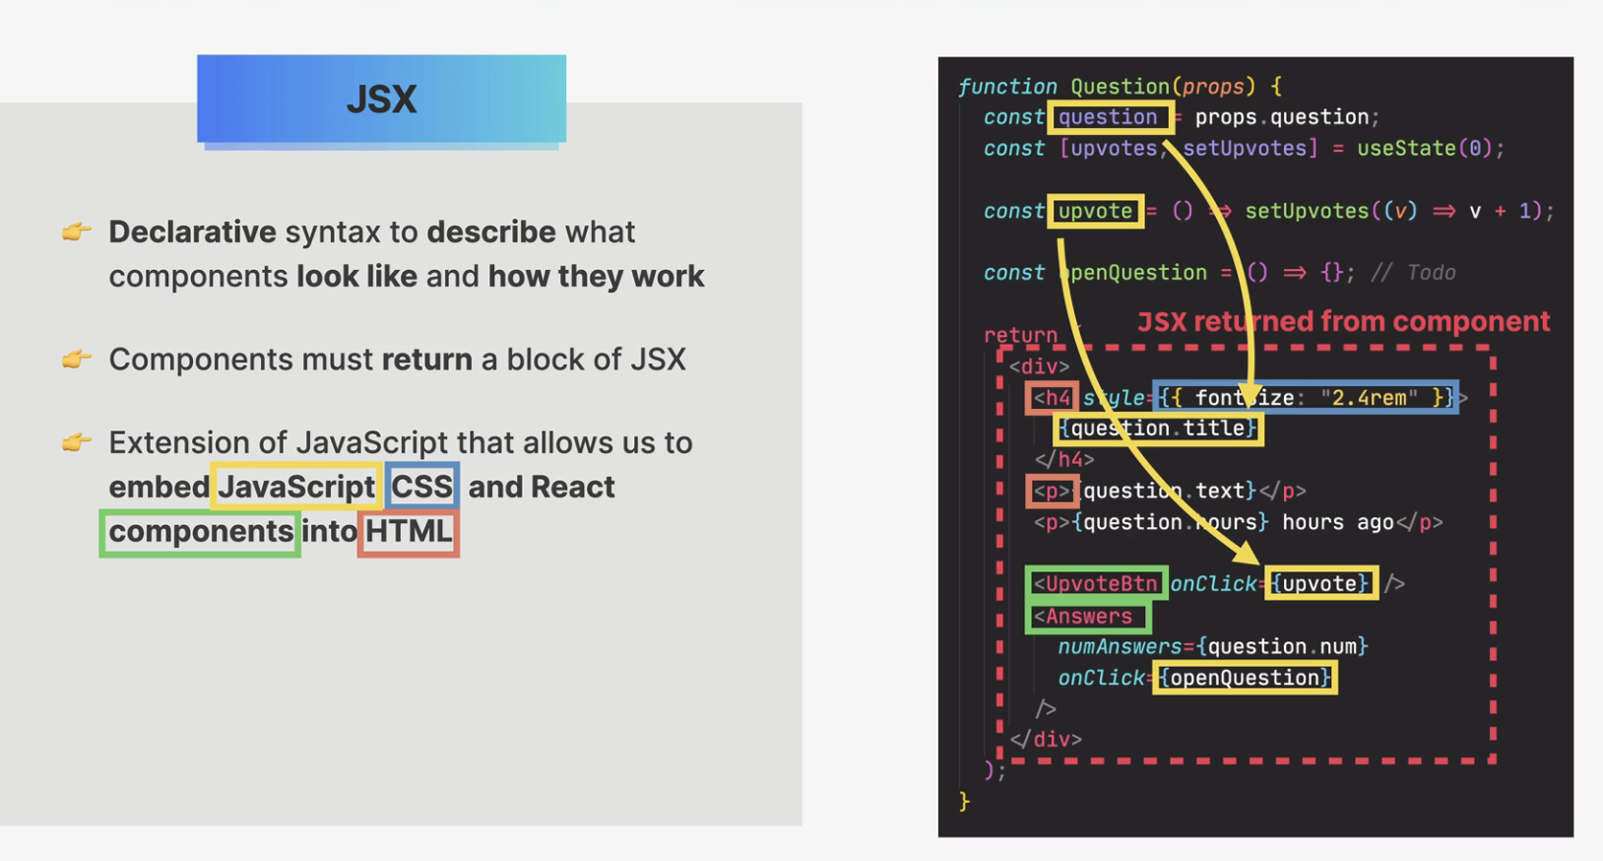

* Each JSX element is converted to a React.createElement function call

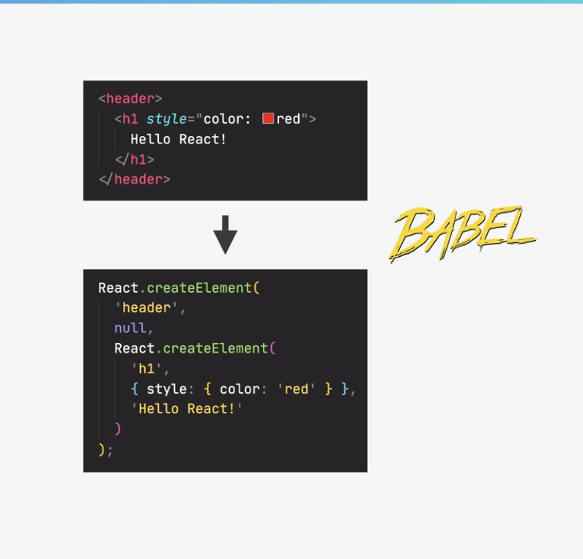

But anyway, this conversion is necessary because browsers of course, do not understand JSX.

They only understand HTML. So behind the scenes, all the JSX that we write is converted into many nested React.createElement function calls. And these function calls are what in the end, create the HTML elements that we see on the screen.

Now, what this means is that we could actually use React without JSX at all.

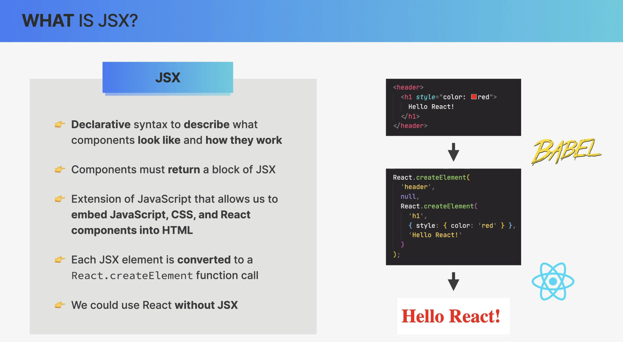

And so again, basically, we use JSX to describe the UI based on props and state. So the data that's currently in the component and all that happens without any DOM manipulation at all.

So, there are no Query selectors, no ad event listeners, no class list, and no text content properties anywhere to be seen here because, in fact, React is basically a huge abstraction away from the DOM, so we, developers never have to touch the DOM directly.

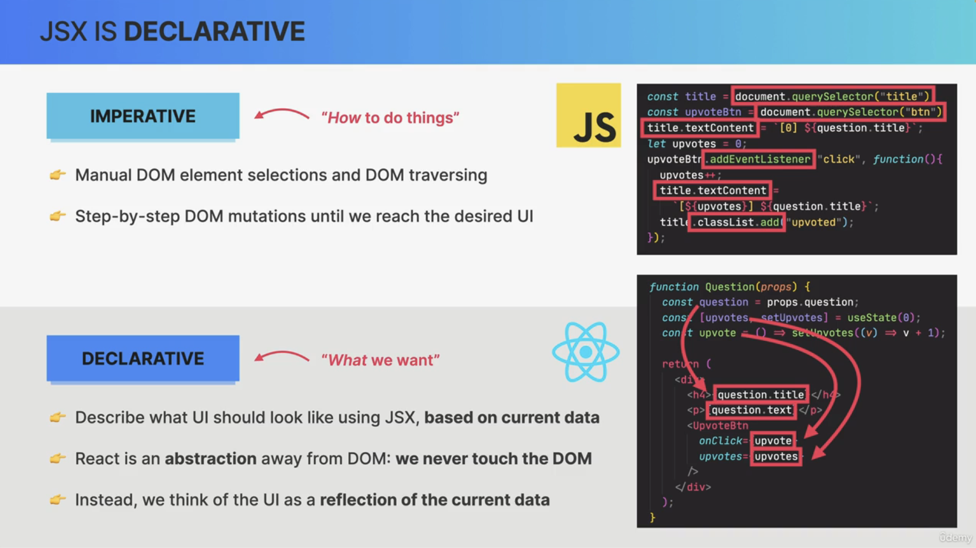

##### Props

And the prop is basically just like parameters to a function.

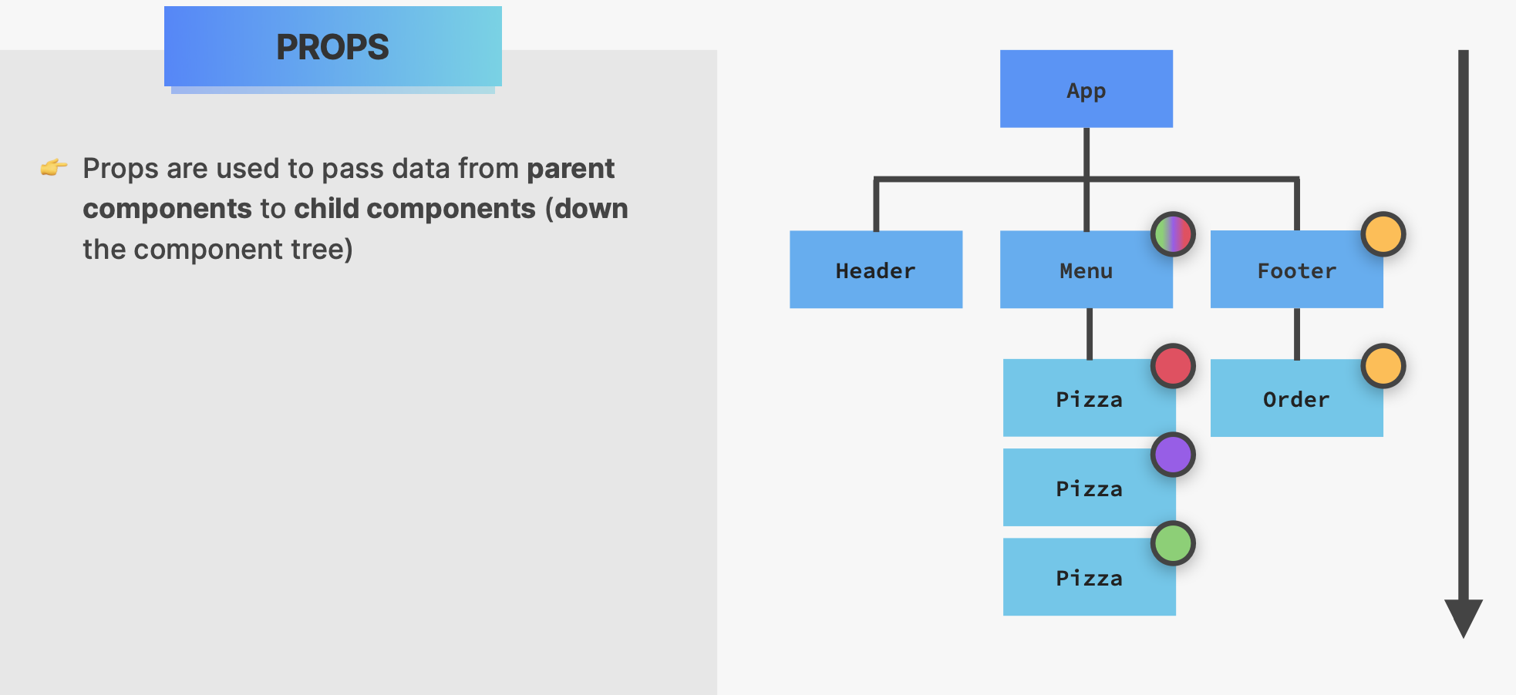

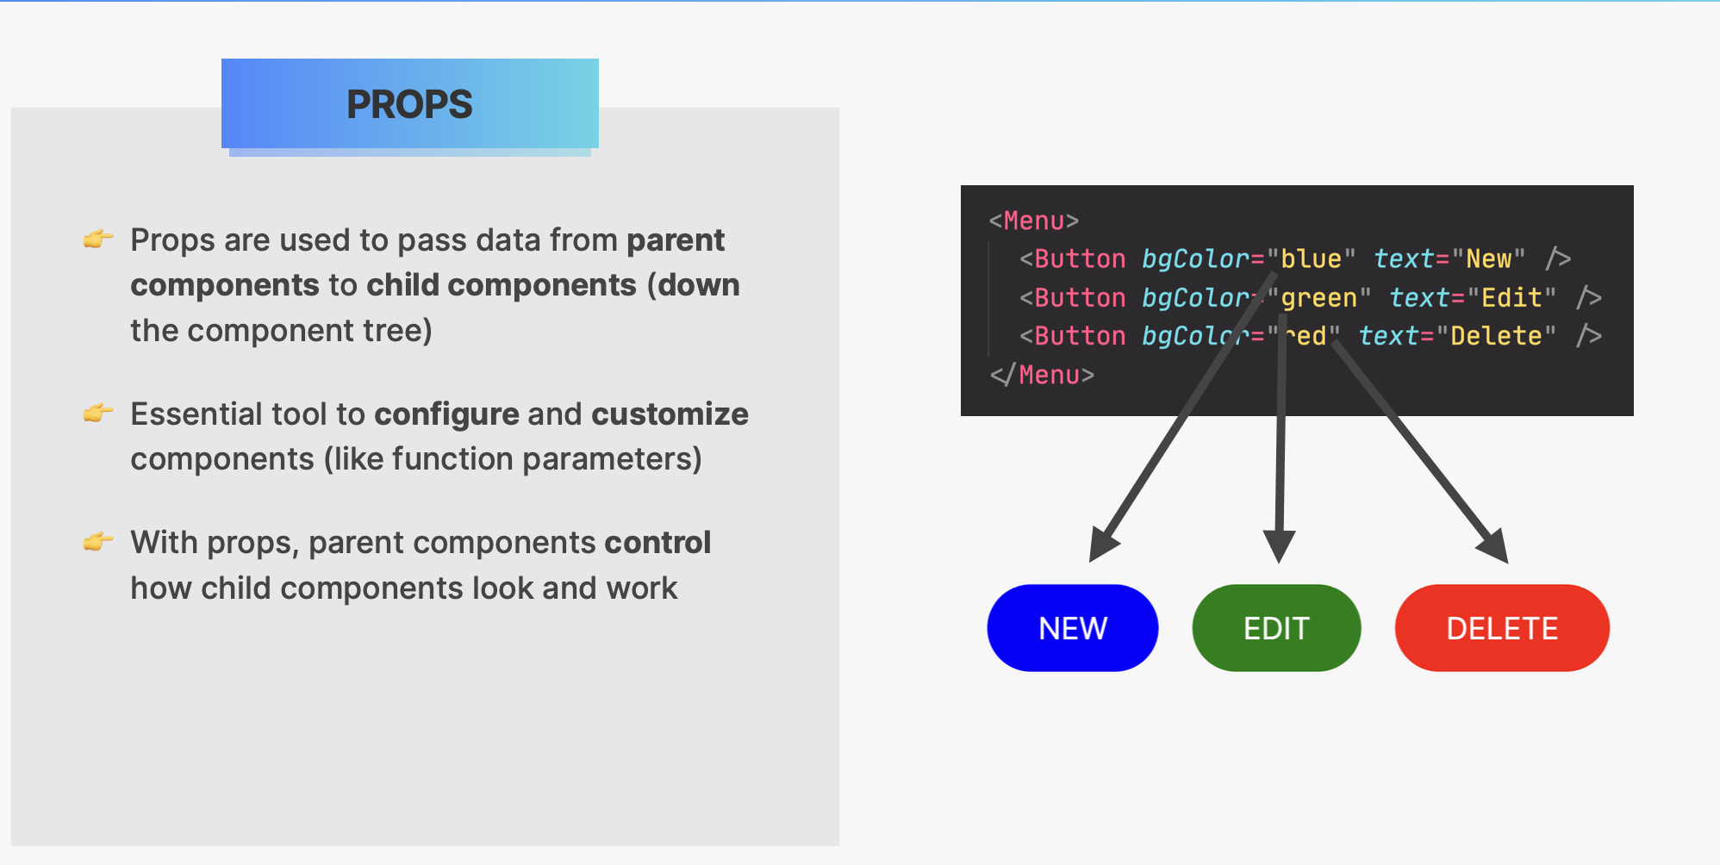

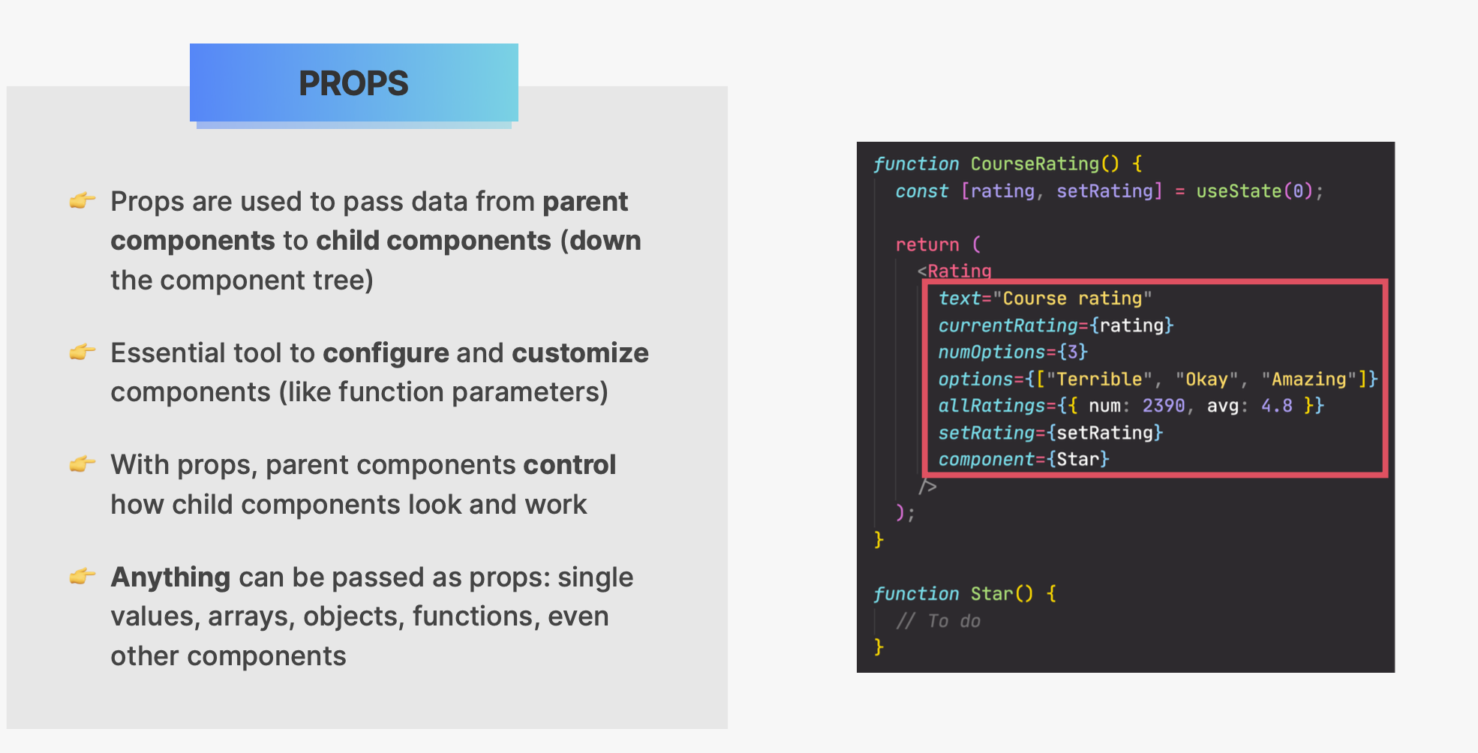

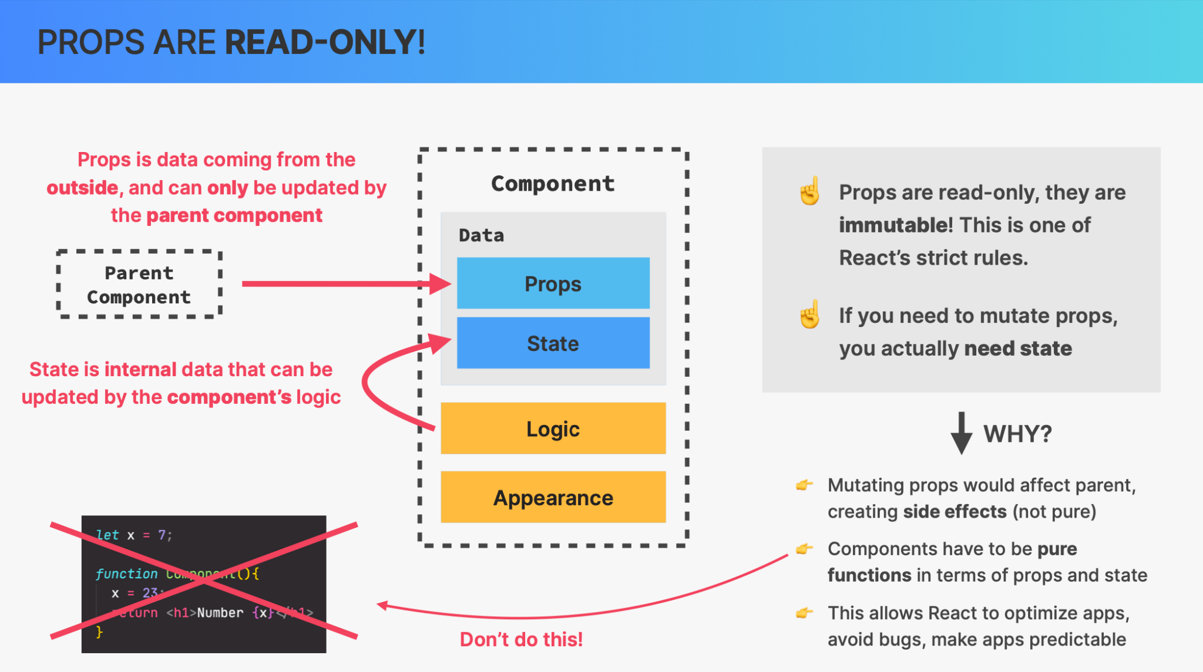

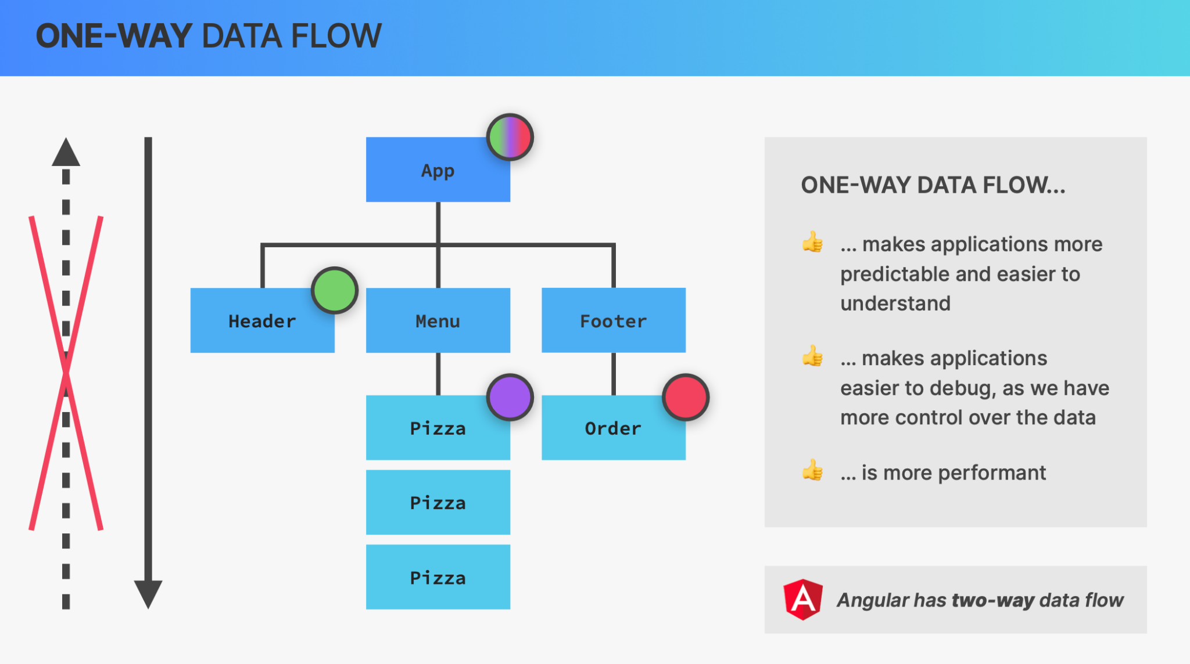

#### Separation of concerns

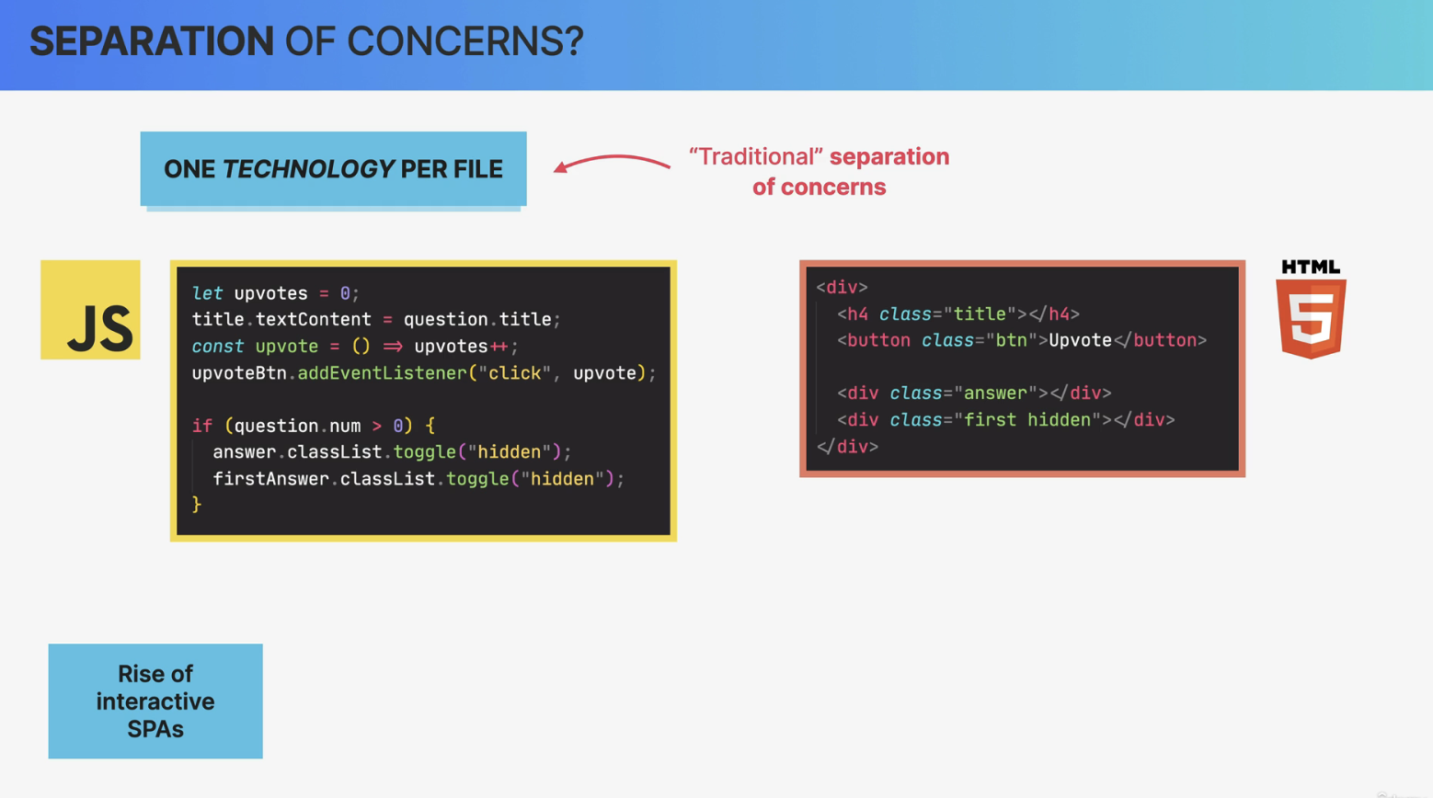

#### 

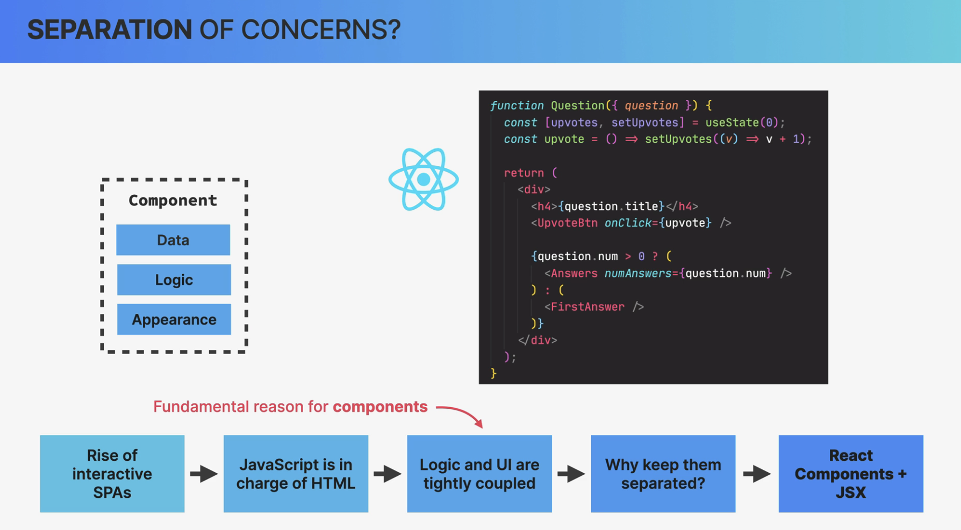

So content and logic are tightly coupled together and so it makes sense that they are co-located here.

Co-located simply means that things that change together should be located as close as possible together.

And in the case of React apps, that means that instead of one technology profile, we have one component profile. So one component that contains data logic and appearance,

all mixed together.

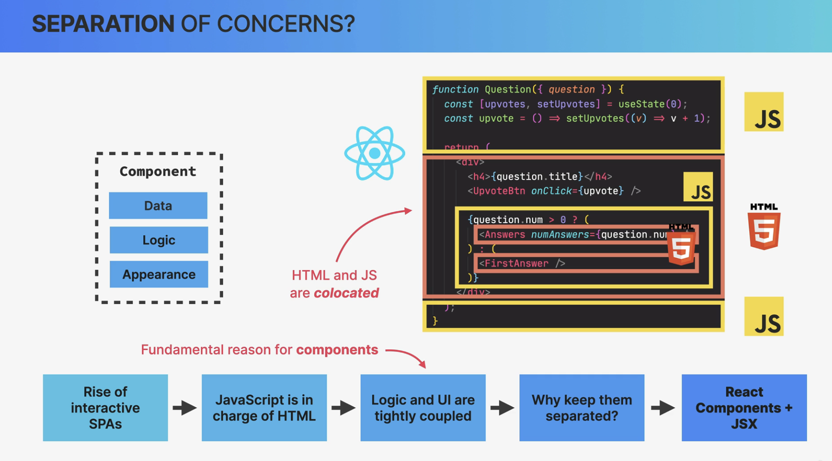

Well, I think that the people who say that React has no separation of concerns, got it all wrong.

Because React does actually have a separation of concerns. It's just not one concern per file,

as we had traditionally but one concern per component.

So each component is in fact, only concerned with one piece of the UI.

Then within each of these components, of course we still have the three concerns of HTML, CSS, and JavaScript all mixed up, as we have been discussing.

So compared to the traditional separation of concerns, this is a completely new paradigm that many people were really not used to in the beginning. But now, many years later, we all got used to this and it works just great.

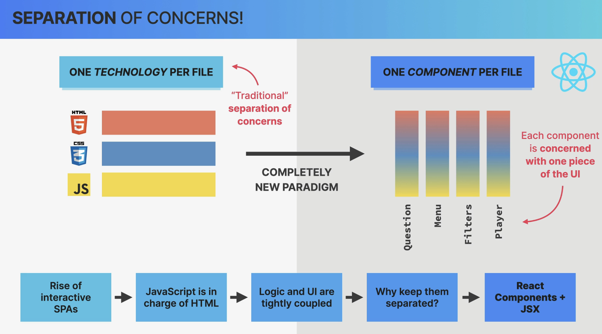

#### State

And the state is the most fundamental concept of React. So whenever we need something to change in the user interface, we change the state. So we update something that we call state.

##### useState

So this useState here is a React function that returns an array.

And so here, we are destructuring that array.

So in the first position of the array, we have the value of the state that we call advice here.

The second value is a setter function.

So a function that we can use to update the piece of state.

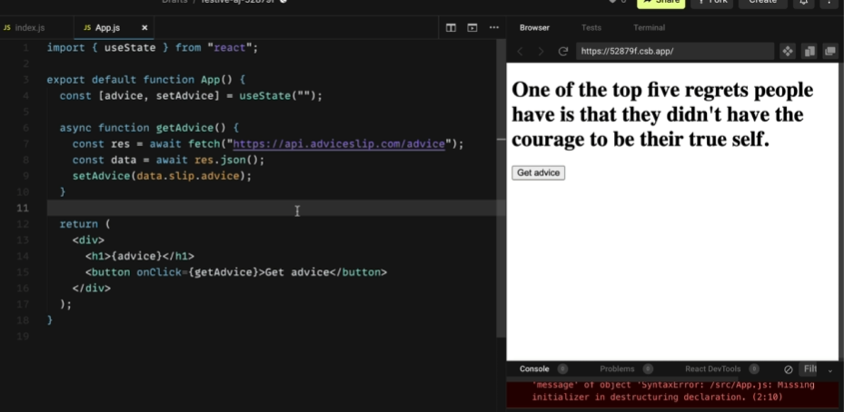

##### useEffect So useEffect takes two arguments. First, a function that we want to get executed at the beginning. So when this component first gets loaded. And then a second argument, which is called the dependency array.

#### Build our first react app

| import { useEffect } from "react"; import { useState } from "react";  function App() {  const [advice, setAdvice] = useState("");  const [count, setCount] = useState(0);  async function getAdvice() {  const res = await fetch("https://api.adviceslip.com/advice");  const data = await res.json();  setAdvice(data.slip.advice);  setCount((c) => c + 1);  }   useEffect(function () {  getAdvice();  }, []);   return (  <div>  <h1>{advice}</h1>  <button onClick={getAdvice}>Get advice</button>  <Message count={count} />  </div>  ); }  function Message(props) {  return (  <p>  You have read <strong>{props.count}</strong> pieces of advice  </p>  ); }  export default App; |
| --- |